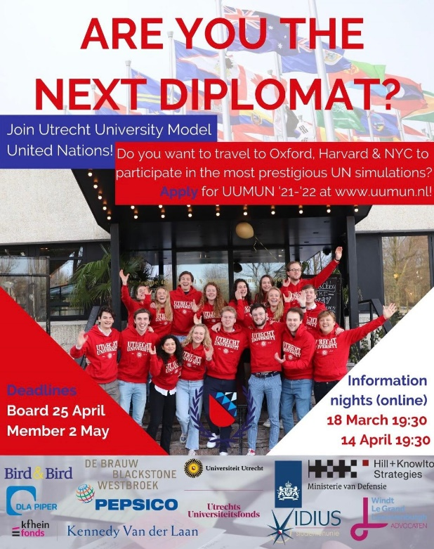
💥APPLY FOR UUMUN💥
Do you want to travel to Oxford, New York and Harvard? Do you want to learn to speech, lobby and negotiate? Would this be even better with a close group of friends from diverse study backgrounds? Then join the Utrecht University Model United Nations delegation 2021-2022!
The ‘red delegation’ will participate in an intensive training program, teaching you all you need to know about speeching, lobbying and international relations! You will travel around the world to represent Utrecht University at the most prestigious United Nations simulations in the world and get in contact with our corporate partners! Don’t miss this amazing opportunity!
To learn more, sign up for our Information Night on the 14th of April (19:30). Everyone who is interested in UUMUN or simply wants to know more about what a year as a UUMUN delegate is like is more than welcome during our Information Night. When you are considering a year at UUMUN we highly recommend you to attend this session. There is room for all your questions!
The deadline to apply for a board position is the 25th of April; the deadline for a member position is the 2nd of May. Follow us on Instagram and Facebook or visit our website www.uumun.nl for the latest updates regarding our activities, the applications and the information night. Also feel free to contact one of our (board) members personally. We are always open to grab a coffee!

